MAIN SUB PAGE
STEEL SIDING & SOFFIT
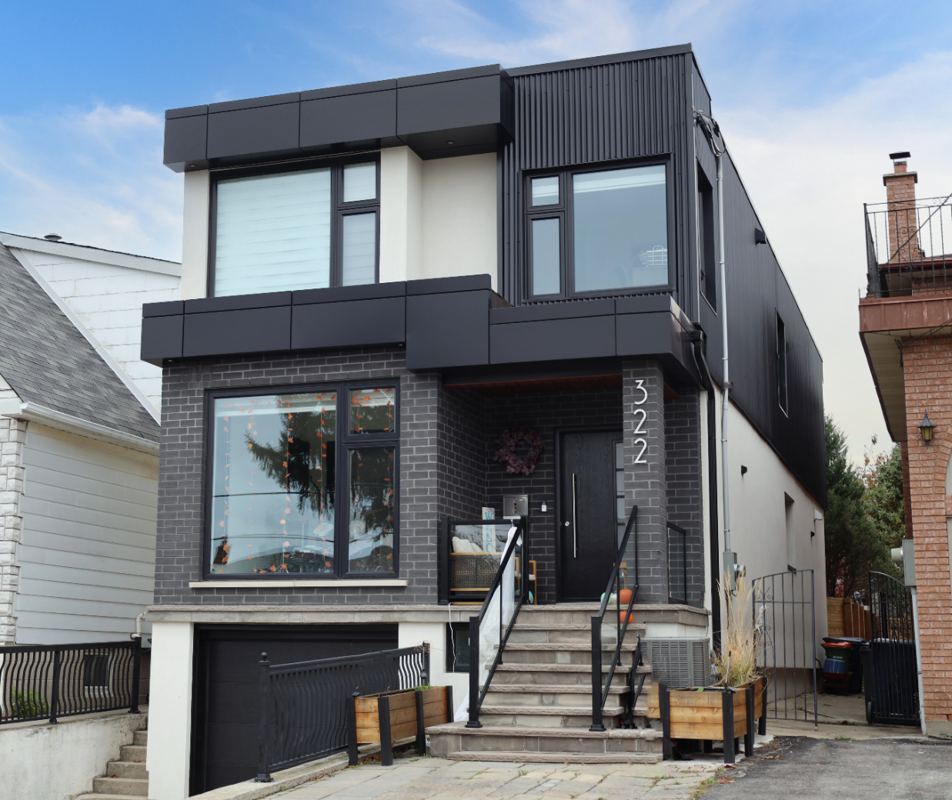
Industrial / Residential / Commercial / Agricultural
Durable, stylish, and cost-effective, metal siding panels offer a modern and long-lasting solution for residential and commercial projects. Made from high-quality steel, these panels provide excellent protection against harsh weather, fire, and pests while enhancing energy efficiency. Their low maintenance requirements and longevity make them a budget-friendly choice over time. With a variety of profiles, finishes, and colors available, metal siding delivers both aesthetic appeal and structural resilience, making it a smart investment for any building.
Curious about the advantages of steel siding? Visit our blog to explore the compelling reasons why this choice stands out for homeowners seeking durability and style.
Speak with an Expert Get personalized advice and expert guidance to achieve your project goals with confidence.
HIDDEN FASTENING (HF) SERIES MENU ICON (PREVIEW)

HIDDEN FASTENER (HF) SERIES Steel Siding & Soffit
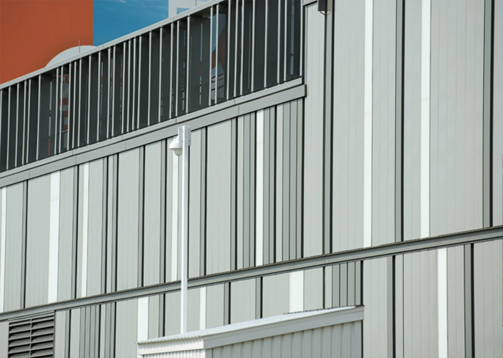
Hidden or Concealed fastening steel siding systems offer a clean, modern aesthetic with exceptional performance across residential, commercial, and industrial applications.... (Learn More / Expand)

HIDDEN FASTENER (HF) SERIES Steel Siding & Soffit (EXPANDED)
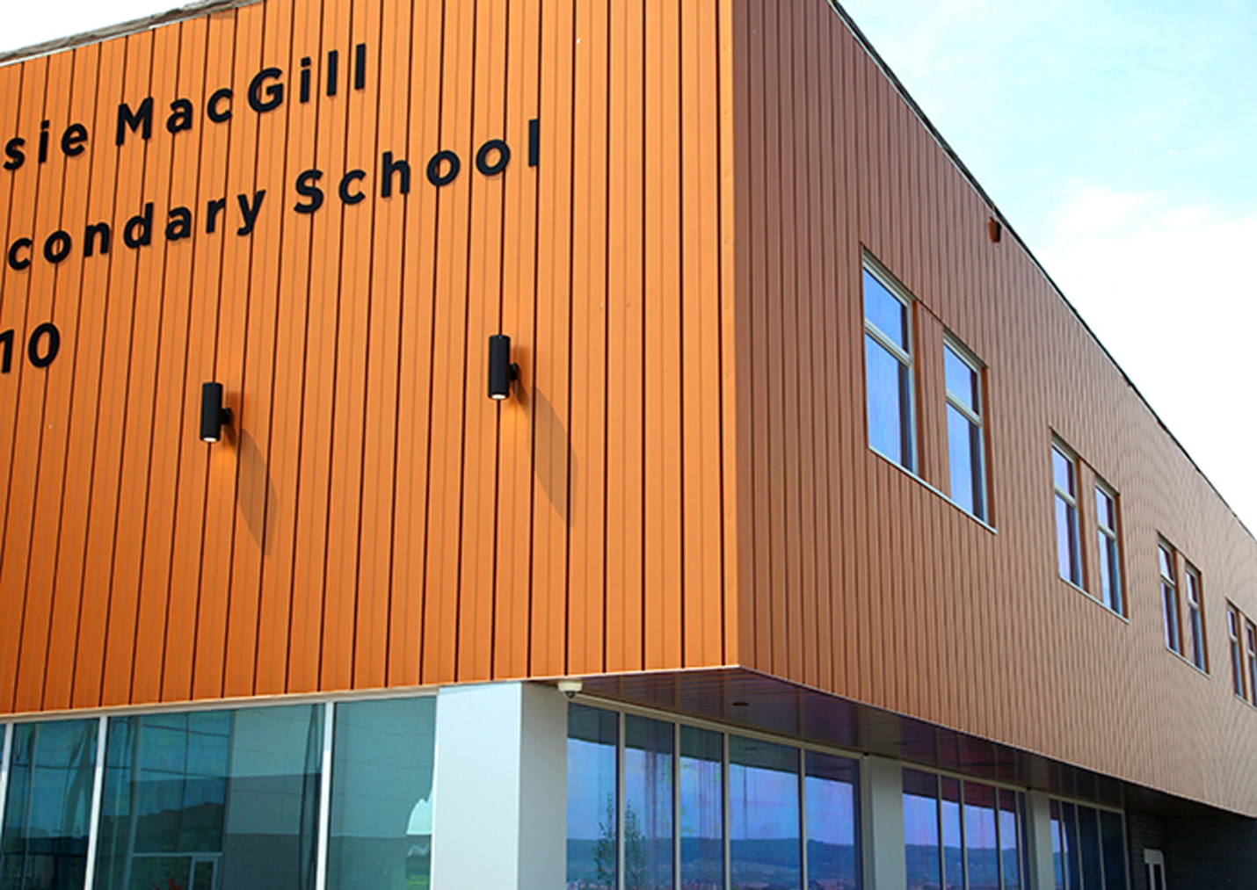
Expanded …By hiding fasteners behind interlocking panels, these systems provide a sleek, uninterrupted exterior surface that enhances visual appeal while improving long-term durability. The concealed design not only protects fasteners from weather exposure and corrosion but also reduces maintenance needs and increases lifespan. With a variety of profiles, colors, and finishes available, these systems deliver both architectural versatility and structural integrity—making them an ideal solution for projects demanding style, strength, and reliability

1- AGWAY MENU ICON (PREVIEW)

Agway Steel Siding & Soffit
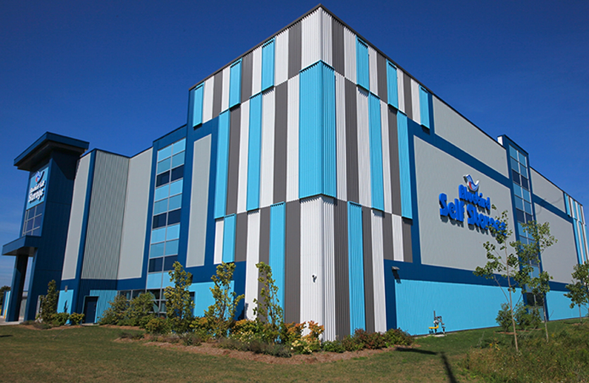
Agway’s Hidden or Concealed fastening steel siding systems offer a clean, modern aesthetic with exceptional performance across residential, commercial, and industrial applications... (Learn More / Expand)

AGWAY® HIDDEN FASTENER (HF) SERIES (EXPANDED)
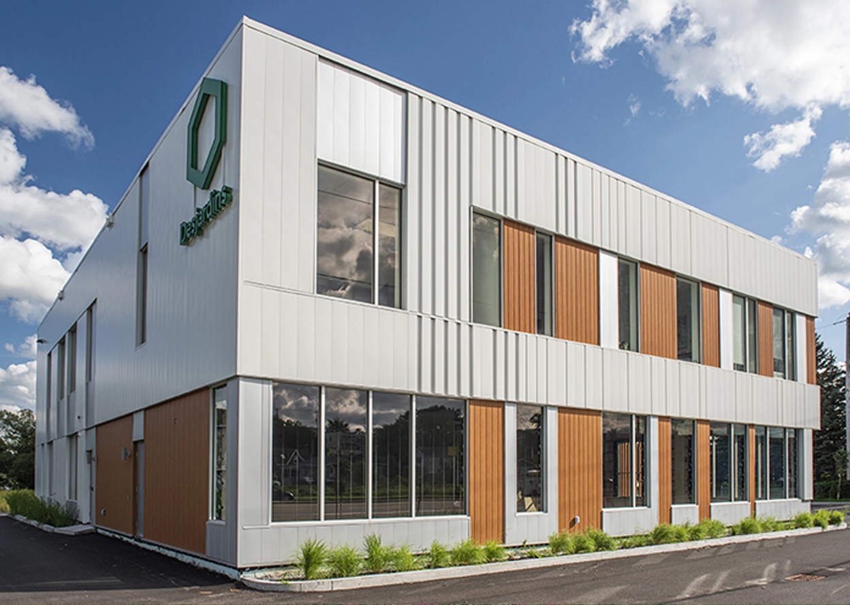
Expanded … Hidden or Concealed fastening steel siding systems offer a clean, modern aesthetic with exceptional performance across residential, commercial, and industrial applications. By hiding fasteners behind interlocking panels, these systems provide a sleek, uninterrupted exterior surface that enhances visual appeal while improving long-term durability. The concealed design not only protects fasteners from weather exposure and corrosion but also reduces maintenance needs and increases lifespan. With a variety of profiles, colors, and finishes available, these systems deliver both architectural versatility and structural integrity—making them an ideal solution for projects demanding style, strength, and reliability.

Profile Options
With a variety of profiles, colors, and finishes available, these systems deliver both architectural versatility and structural integrity—making them an ideal solution for projects demanding style, strength, and reliability.

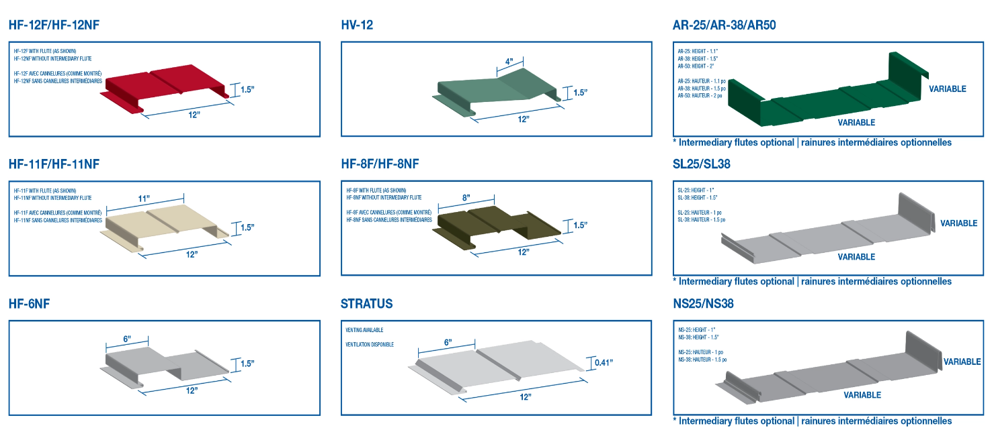

HF-12
The HF-12 Hidden Fastener profile is a top choice for architects seeking a sleek, modern look for institutional, industrial, and commercial projects. With its concealed fasteners and effortless installation, this 12” panel system delivers a smooth, uninterrupted appearance that enhances contemporary designs.

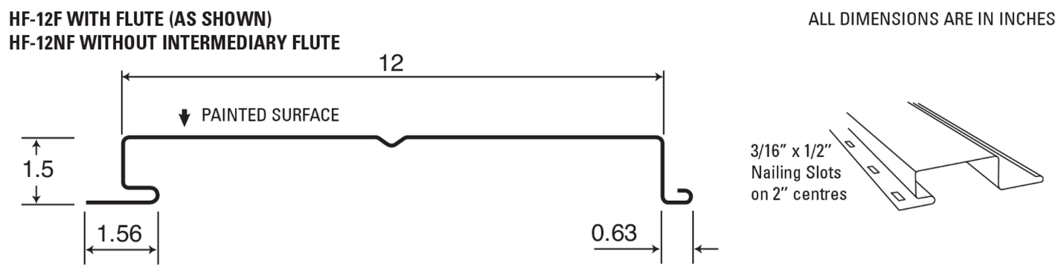
Offered in various gauges and an extensive range of standard and custom colors, the HF-12 provides the flexibility to achieve both structural durability and striking aesthetics, making it a versatile solution for any project.

HF-11
The HF-11 profile adds a refined 1” reveal to Agway’s trusted Hidden Fastener lineup, offering a crisp, modern surface finish favored in today’s architectural designs.

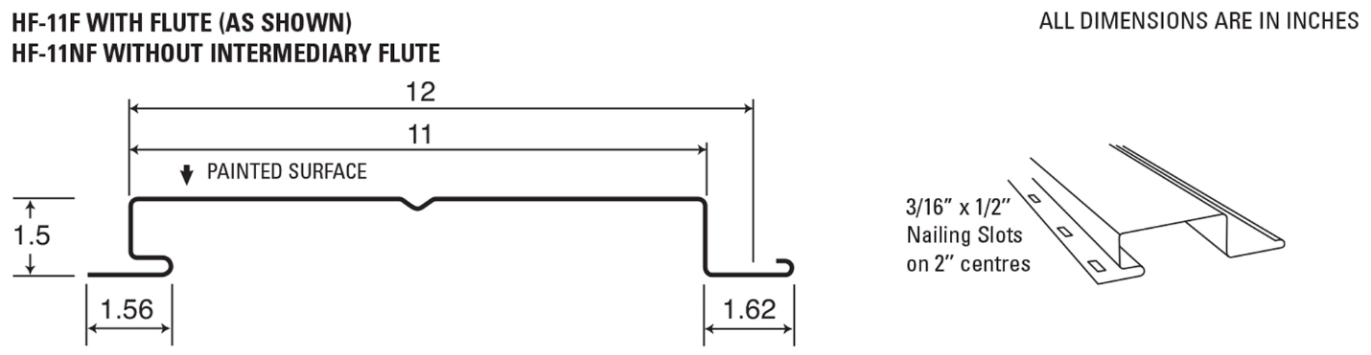
Available in multiple gauges and a wide selection of standard and custom colors, HF-11 empowers designers and builders to balance visual appeal with structural performance—tailoring the solution to meet both aesthetic goals and practical demands.

HV-12
Expanding the possibilities for modern commercial design, crafted specifically to give architects greater flexibility and creative control.

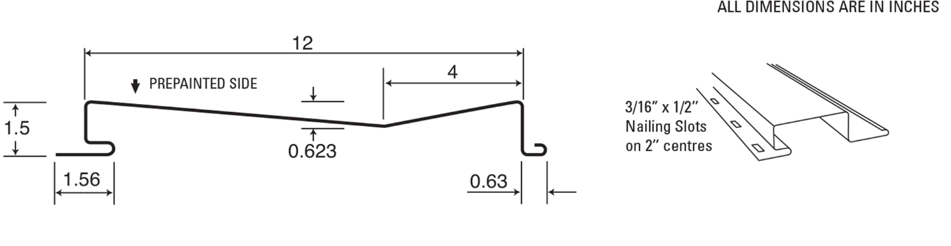
This new profile adds a refined, distinctive look to exterior cladding, offering a fresh option for projects that call for something visually understated yet unique.

HF-8
The HF-8 combines the advantages of our renowned Hidden Fastener system with a distinctive board and batten look.

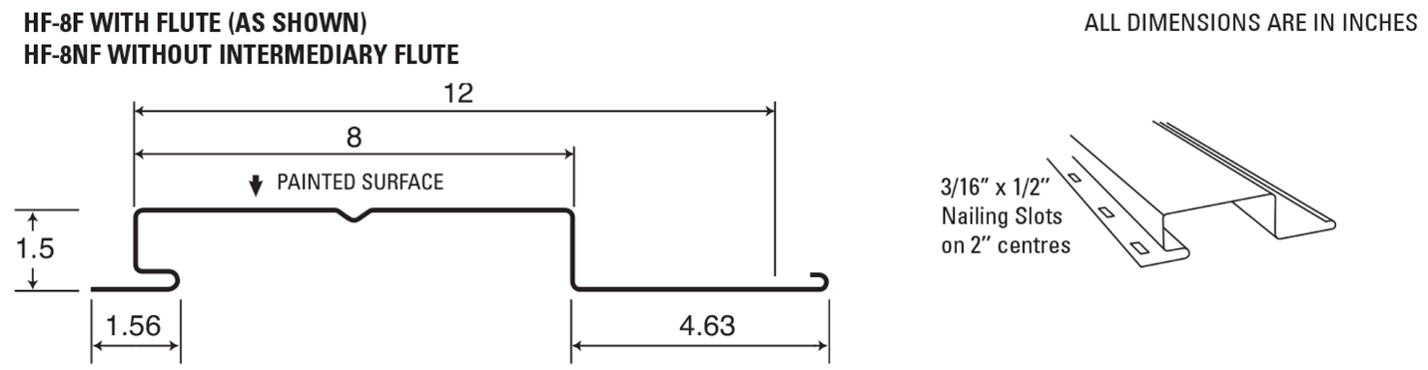

This 12” wide panel, featuring a 4” return, offers a bold yet refined aesthetic, making it an excellent choice for institutional, industrial, and commercial applications.

HF-6
Built on the proven performance of the Hidden Fastener system, the HF-6 profile introduces a bold visual identity with its 12” panel width and 6” return.

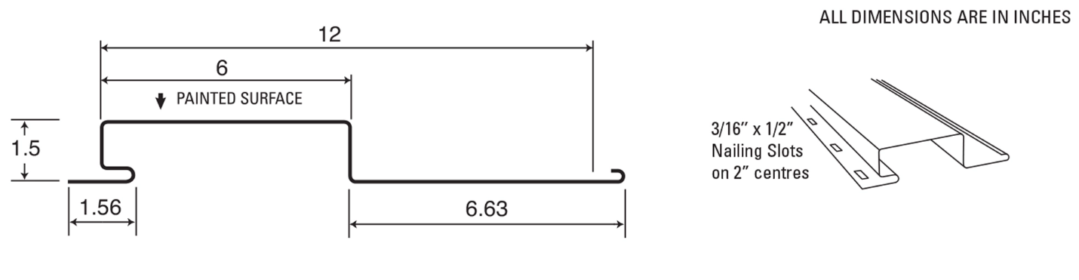

Its crisp, streamlined look makes it a standout choice for commercial, industrial, and institutional buildings aiming for a clean, contemporary edge.

Decorative Hidden Fastener Panel (Brake-formed)
Cladcan’s Hidden Fastener Decorative Metal Panels offer a versatile and stylish solution for walls, fascia, and soffits. Designed for both function and aesthetics, these panels are available in custom lengths up to 20’ and come in a variety of colors.

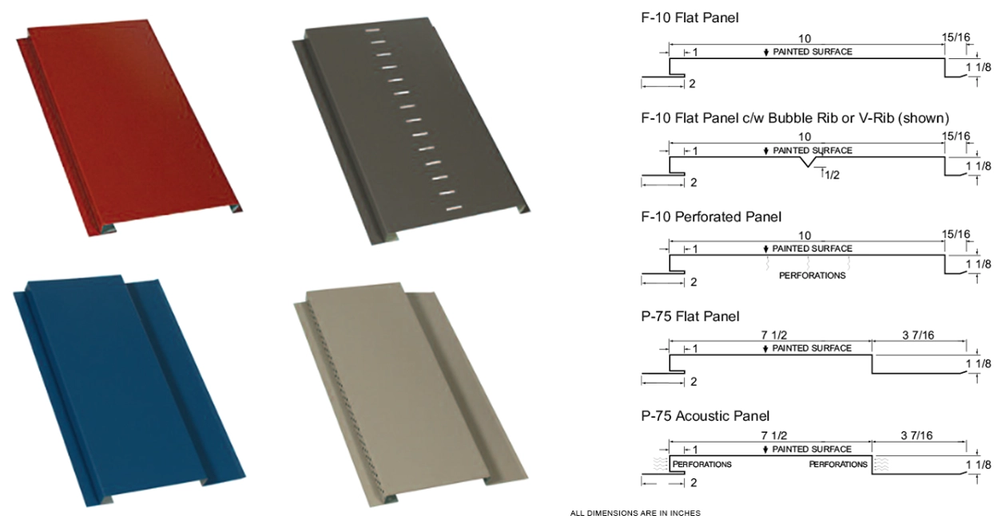

With options for vented (round or slotted holes) and non-vented designs, they provide flexibility for different applications. Plus, with immediate availability, they’re a convenient choice for any project.

Features
- Wall, Fascia or Soffit applications
- Custom lengths from 1’-0” to 20’-2”
- Excellent colour selection for immediate shipment
- Preprinted Steel, Aluminum, Copper, Stainless Steel and Zinc
- Custom dimensioning also available
- Venting available in round or slotted holes
- Stiffener ribs available in V-Rib or Bubble Rib
Maximum length: V-Rib: 12’ – 0”, Bubble Rib: 10’ – 0”
- Available in 26 ga. and 24 ga.
- Attractive appearance
- Easy Soffit installation – secure with screws or nails to underside of overhang

Additional Notes:
- Please note: Oil canning may naturally occur due to material and installation variables.
- This is a visual phenomenon and does not qualify as a product defect.

Color chart

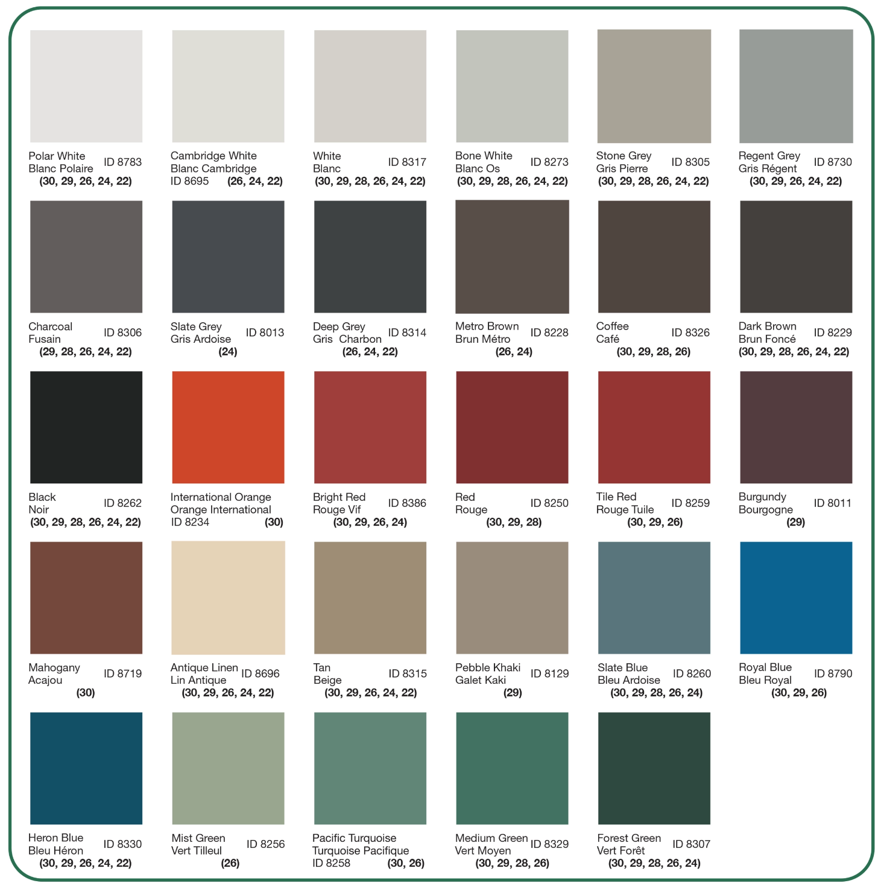

Standard and Custom Flashings
If you need a specific flashing shape, we can fabricate it. Cladcan provides a full range of flashings and trims to complete your commercial or industrial building project. From outside corners to jambs and coping flashings, we’ve got you covered.

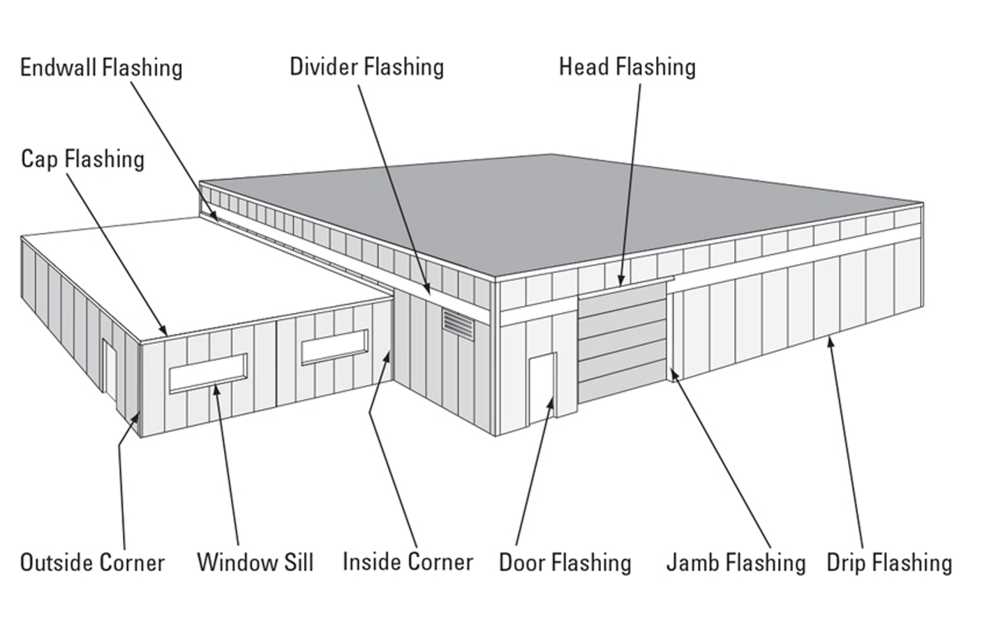
Outside and Inside Corners
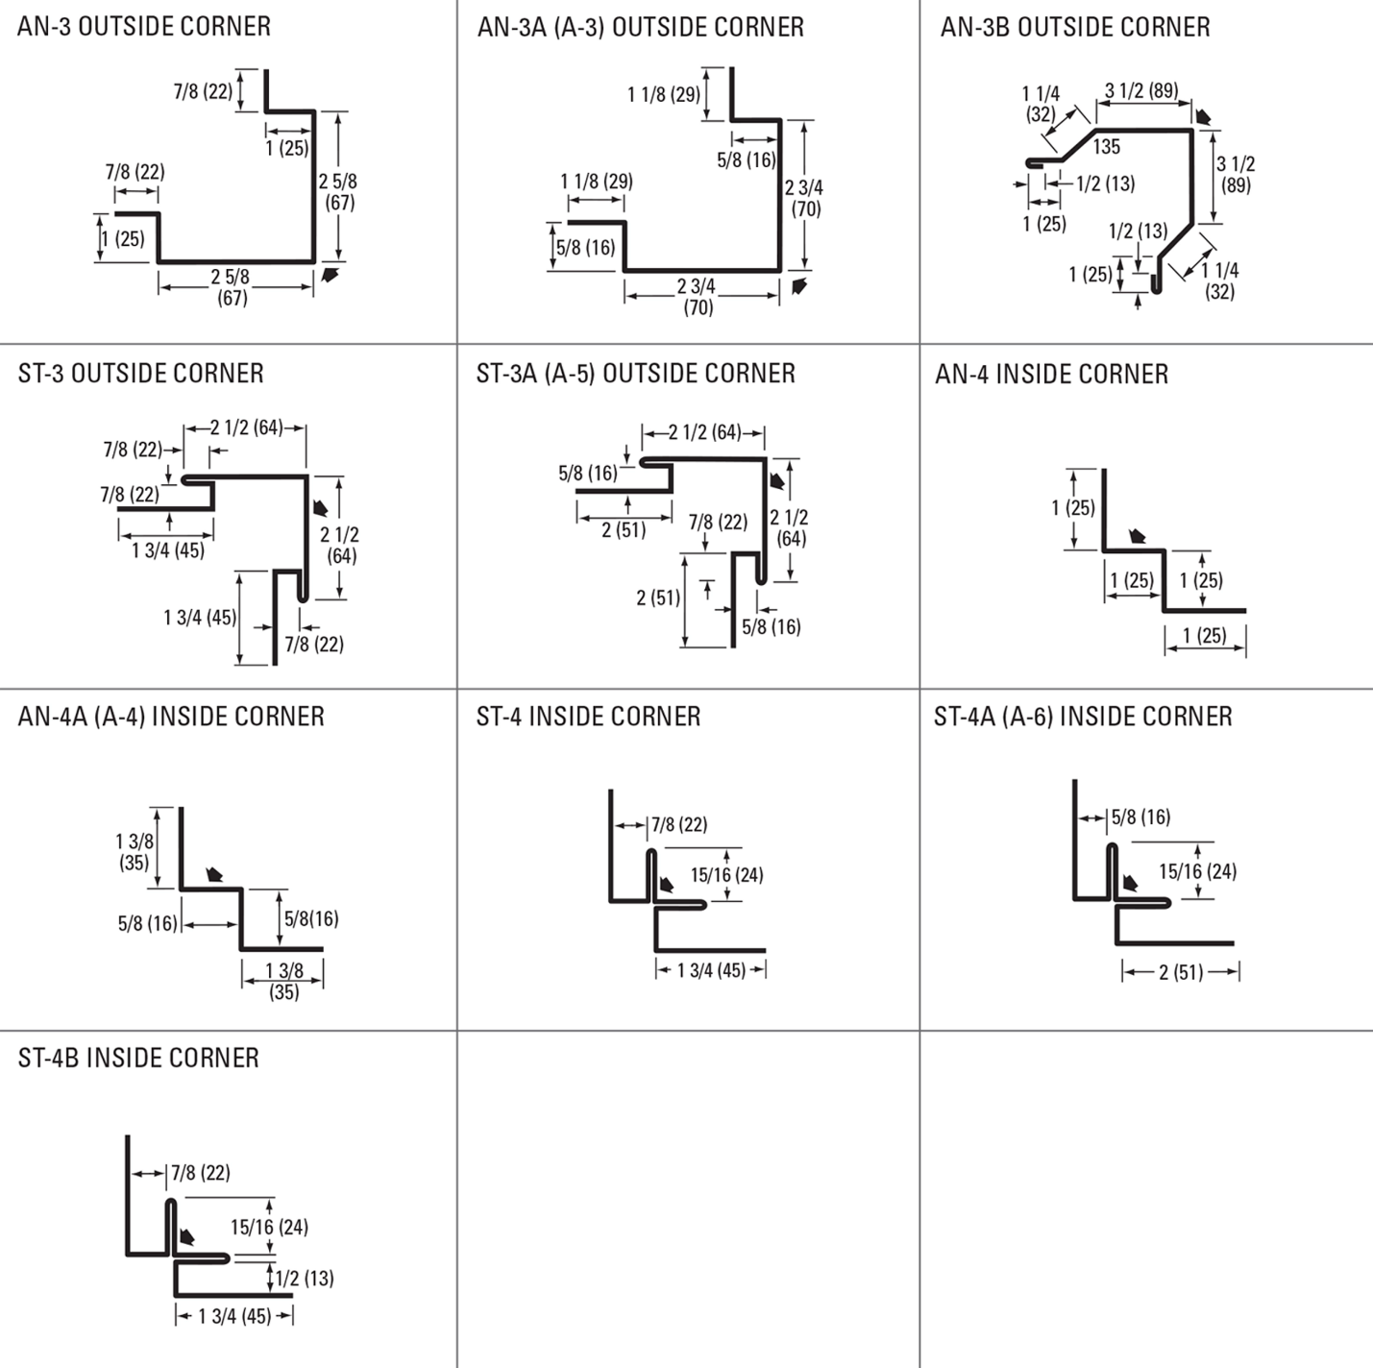

Drip and base Trims, Gable Dividers
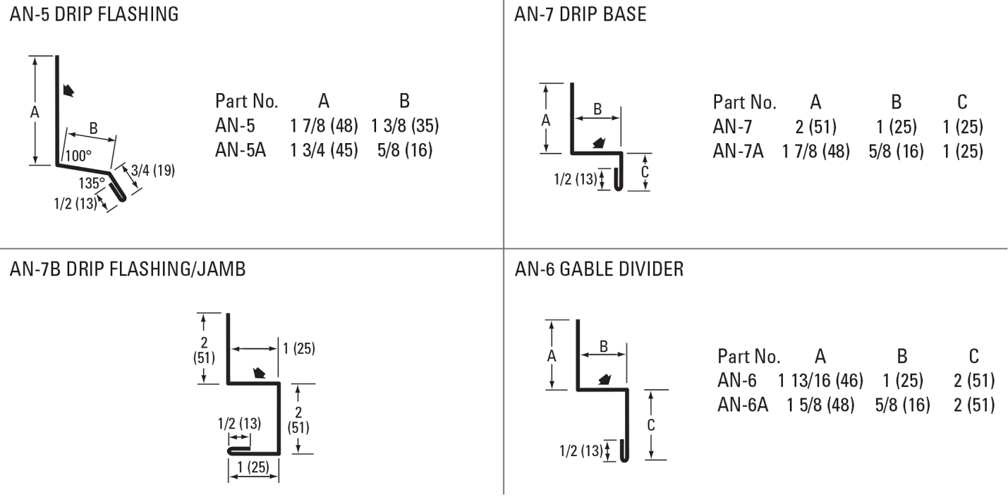
Soffit & Gable Trims, Eaves Starters, Jamb Fkashings
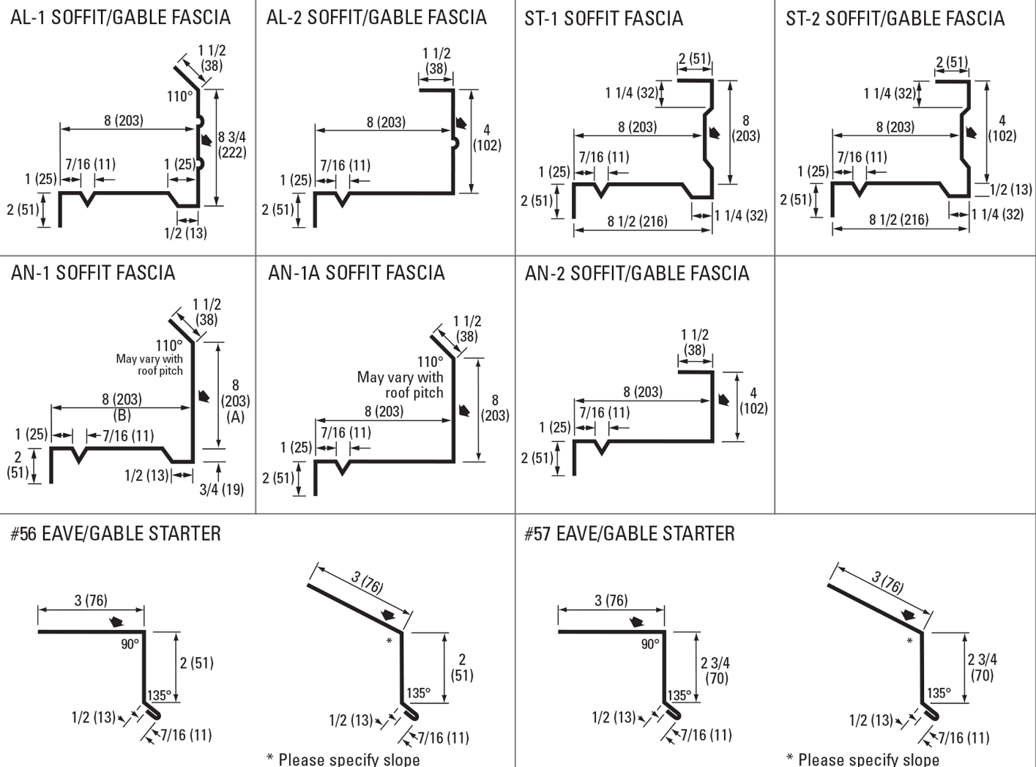
Hip Flashings, Endwalls, J-Trims, Ceiling & Sliding Door Trims
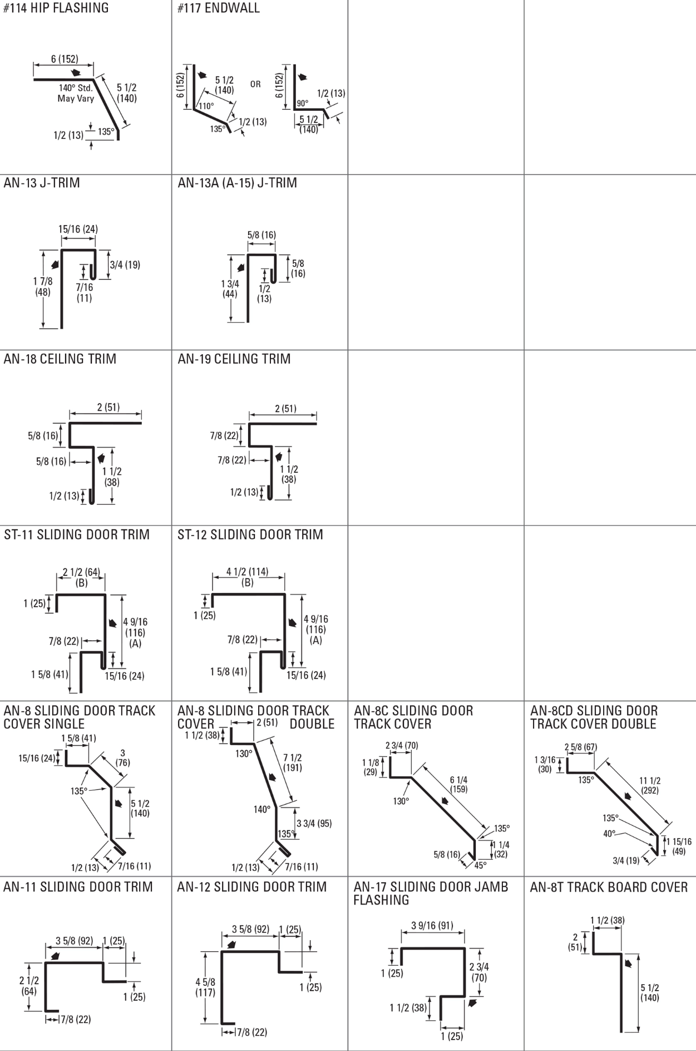
Finishes Perspectra Plus Series™
The Perspectra Plus Series™ represents the next evolution of our Perspectra Series® paint system. Enhanced with advanced Silicone Modified Polyester (SMP) technology and a new resin backbone, it offers superior resistance to chalking, fading, chemical degradation, and scratching.
Designed for maximum durability, the Perspectra Plus Series™ provides exceptional colour fade resistance, improved gloss retention, and increased scratch resistance. With a proven track record, it ensures 40 years of film integrity and 30 years of reliable colour and chalk resistance, making it ideal for roofing and cladding applications across Canada and the continental US.
Available on hot-dip galvanized steel and Galvalume™ (55% Aluminum – 45% Zinc alloy coating), the Perspectra Plus Series™ guarantees long-lasting performance and outstanding protection.

